**National Public School, Koramangala 2021-22**

**Computer Science Assignment -2**

**Conditional Statements**

**Grade: 11**

1. Write a Python script that will help calculate the total resistance when ***two resistors*** are connected either in series or in parallel.

Accept the resistance in Ohms and the type of connection (Series or Parallel) and calculate the total resistance.

Formulae: When R1 and R2 are connected in series, total resistance is R1+R2.

When R1 and R2 are connected in parallel, total resistance is $\frac{R1*R2}{R1+R2}$

1. Write a Python script to accept coordinates of a point in the XY coordinate system from the user and determine in which quadrant the coordinate point lies.

For example (3,4) lies in the first quadrant.

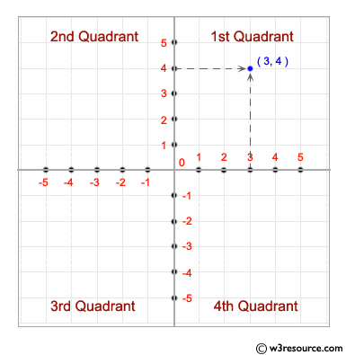

1. Write a Python script to accept a year from the user and check whether it is a leap year nor not.
2. A dartboard of radius 10 units and the wall it is hanging on are represented using a two-dimensional coordinate system, with the board’s centre at coordinate (0,0). Variables x and y store the x-coordinate and the y-coordinate of a dart that hits the dartboard. Write a Python script to accept the coordinates of the point hit by the dart and display whether the dart hit is within the dartboard or not.
3. Write a Python script to accept 3 numbers from the user and display them in descending order.

*(Hint: find max, min and mid = (sum of nos. – (max+min))*

*Note: Inbuilt functions are not to be used.*

*[P.T.O]*

1. An electricity supply company charges customers *INCREMENTALLY* based on the following slabs:

|  |  |  |
| --- | --- | --- |
| **Slab** | **Units Consumed** | **Price per Unit** |
| S1 | 1-100 | Rs.3 |
| S2 | 101-150 | Rs.5 |
| S3 | >150 | Rs.7 |

Write a Python script that accepts customer name and the no. of units of electricity consumed and generates the bill according to the following format:

Customer Name:

No. of units :

Total Bill : Rs.

For example, if a customer’s electricity consumption is 175 units, bill amount = (100*3) + (50*5) + (25*7) = Rs.725

1. Write a program that asks the user for an hour between 1 and 12, asks them to enter am or pm,

and asks them how many hours into the future they want to go. Print out the time that many hours   
 into the future,with am or pm as appropriate. An example is shown below.

Enter hour: 8

am (1) or pm (2)? 1

How many hours ahead? 5

New hour: 1 pm

*****************************